**Test Case 13**

**System:** Bench

**Description:** Test that the user is able to schedule an event with a person they want in the calendar.

**Severity:** 4

**Instructions**

**Test 1**

1. Start the Bench application.
2. Click the button “Login” on the navigation bar.
3. Enter the email “team23project@gmail.com” into the text field labeled “Email address”.
4. Enter the password “12345678” into the field labeled “Password”.
5. Click the button “Login” below the field.
6. After the screen has loaded, click on the button “My Event” on the navigation bar.

**Expected Result:** There should be a panel with the option to input another user’s email on the calendar labeled “Partner’s Email”.

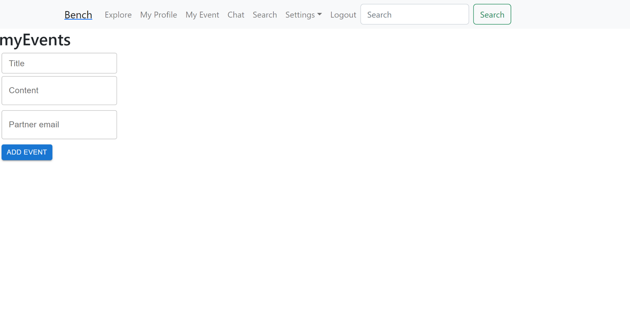

**Test 2**

1. Start the Bench application.
2. Click the button “Login” on the navigation bar.
3. Enter the email “team23project@gmail.com” into the text field labeled “Email address”.
4. Enter the password “12345678” into the field labeled “Password”.
5. Click the button “Login” below the field.
6. After the screen has loaded, click on the button “My Event” on the navigation bar.
7. In an empty panel on the My Event page, enter inputs into the field “Title”, “Content”, and “Partner email”.
8. Click on the button “Add Event”.

**Expected Result:** There should appear a scheduled event panel with the previously-inputted information on the sender user’s My Event page, and the same scheduled event panel on the Partner’s My Event page. In this case, because both the sender and the Partner is user TEAM 23, there should appear two of the same scheduled event panel on TEAM 23’s My Event page.

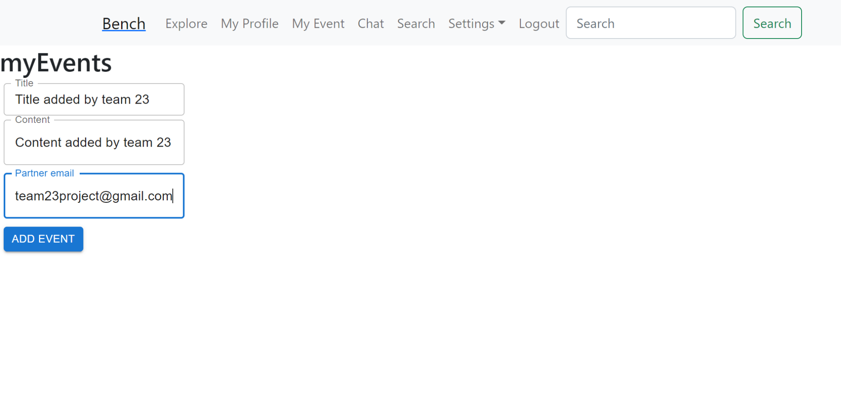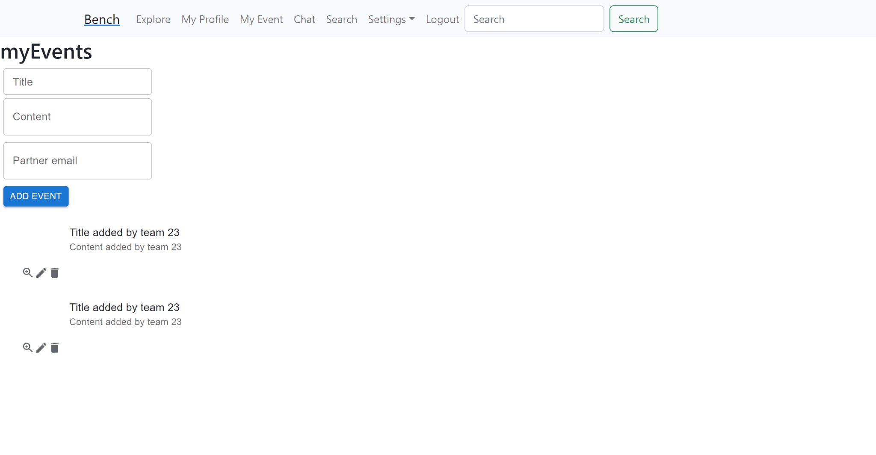

**Test 3**

1. Start the Bench application.
2. Click the button “Login” on the navigation bar.
3. Enter the email “team23project@gmail.com” into the text field labeled “Email address”.
4. Enter the password “12345678” into the field labeled “Password”.
5. Click the button “Login” below the field.
6. After the screen has loaded, click on the button “My Event” on the navigation bar.
7. In an empty panel on the My Event page, enter inputs into the field “Title”, “Content”, and “Partner email”.
8. Click on the button “Add Event”.
9. There should appear a scheduled event panel with the previously-inputted information on the sender user’s My Event page, and the same scheduled event panel on the Partner’s My Event page. In this case, because both the sender and the Partner is user TEAM 23, there should appear two of the same scheduled event panel on TEAM 23’s My Event page.

**Expected Result:** All of this UI changes should be updated immediately once teh button “Add Event” is clicked.

